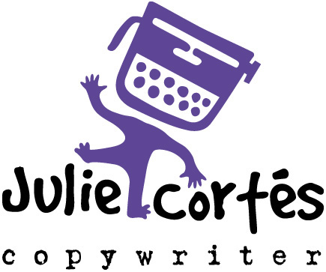
5919 W. 152nd Terr.
Overland Park, KS 66223
913.851.4355 (o)
913.484.8350 (c)
BIO
CopyDiva—Exposed
For nearly 20 years, I’ve run my own copywriting and proofreading business, working with advertising agencies, design shops and companies of all shapes and sizes, helping them meet their marketing goals through entertaining and results-driven copy. I’m recognized for my unique ability to create and maintain a personality and voice for each client. Plus, I’m able to see the big picture, manage deadlines and work within all budgets and forms of media, like:

• Print • Web • Newsletter • Brochure • B-to-B
• TV • Interactive • Direct Mail • Collateral • B-to-C
• Radio • PR • Annual Report • Video • And more

I have an agency and corporate background, plus experience in the following industries:

• Real Estate / Development • Architecture / Construction • Banking / Financial
• Health Care / Insurance • Telecom / Electronics • Industrial / Engineering
• Fashion / Jewelry • Restaurant / Food Service • Retail / Service / Education
• Fitness / Outdoorsman • Senior / Kids Marketing • And many, many more

Pats on the Back
AAAs / Addys / Omnis — given by The Advertising Advertising Federation of Kansas City (AAF)
9 awards — Gold, Silver and Bronze
Member of the Year award for volunteer service—2001
Fountains — given by The Business Marketing Association of Kansas City (BMA)
6 awards — all Gold
Freebés — given by The Freelance Exchange of Kansas City (FX)
31 awards — Gold, Silver and Certificates of Merit
Best of Show in Copywriting—2008
Freelance Flame award for devotion, inspiration & leadership—2005
Ambits — given by The Direct Marketing Association of Kansas City (DMA)
1 award — Silver
MAMEs — given by the Home Builders Association of Greater Kansas City (HBA)
7 awards — all Gold Metropolitan Awards for Marketing Excellence

Beyond the Call of Duty
The Freelance Exchange of KC
Founder, President, Past President; Member & Board Member since inception: 2003
American Advertising Federation (AAF, formerly Ad Club)
Ad2 Communications Director, President, Immediate Past President, Active Member
The Creative Club of KC
Communications/ PR Director; Member through duration: 2002-2003

